The Inorganic That You Don’t Need to Know

**Redox:**

* Equation balanced
  + Calculate the oxidation number of each elements and ions
  + Calculate the number of electron transfer based on the change in oxidizing number and use this as the ratio for the calculation
  + Then balanced all the rest of equation number
  + For disproportion noticed that there must be a pair of change – to increase must be balanced by decrease in oxidizing number
* Reaction of Halide with conc. H2SO4

|  |  |  |
| --- | --- | --- |
| Reaction | Formula | Observation |
| Cl- | H2SO4 + NaCl -> NaHSO4 + HCl | Steamy fumes(HCl) |
| Br- | H2SO4 + NaBr -> NaHSO4 + HBr  HBr + H2SO4 -> Br2+SO2+H2O | Steamy fumes(HBr)  Orange Brown Vapor(Br2) |
| I- | H2SO4 + NaI -> NaHSO4 + HI  AND  8HI + H2SO4 ->4I2 + H2S +4H2O  OR  6HI + H2SO4 -> 3I2 + S+4H2O | Purple vapor(I2)  Foul smell(H2S)  Yellow solid(S) |

This is because X- are strong reducing agent and they have the ability to reduced others(S in this case)

This power decrease down the group, therefore the S gets more and more reduced(from +6 -> +4 ->-2/0)

This could happen also because H2SO4 is a strong oxidisng agent, and that was not possible with non-oxidizing acid like H3PO4

The overall formula can be produced by adding the separate formula with equilibrium balanced

**Period 3/Precocity:**

* Physical properties
  + Atomic radius/Ionic radius

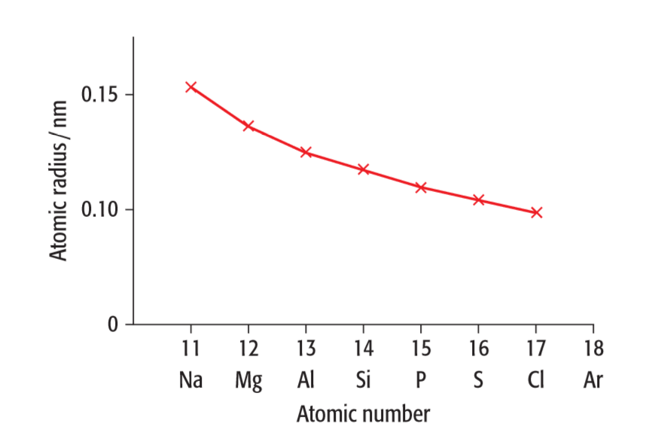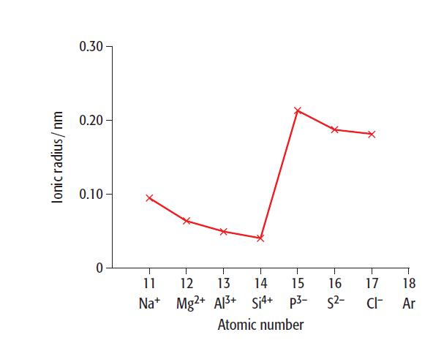



Ionic radius

Atomic radius

* + - Factor affecting atomic radius

1. The number of shells of electron
2. The effective nuclear charge cause by the shielding effect of the inner electron shell
3. The attraction because of the nucleus charge

You can answer by the form of argument like this:

the increase attraction of the nucleus charge out weight the increase of distance between the nucleus and electron, since the shielding effect from the nucleus is constant so the atomic radius decrease

* + - Factor affecting ionic radius

1. The charge of the ions(+/-)
2. The effective nucleus charge
3. The number of electron gain/loss

If the electron loss electron, then the more it loss, the stronger the effective nucleus charge is and thus results in the smaller ionic radius

If the electron gain electron, then the more it gain, the stronger the repusion between the electron it will be, and thus results in the larger ionic radius

* + First ionization energy

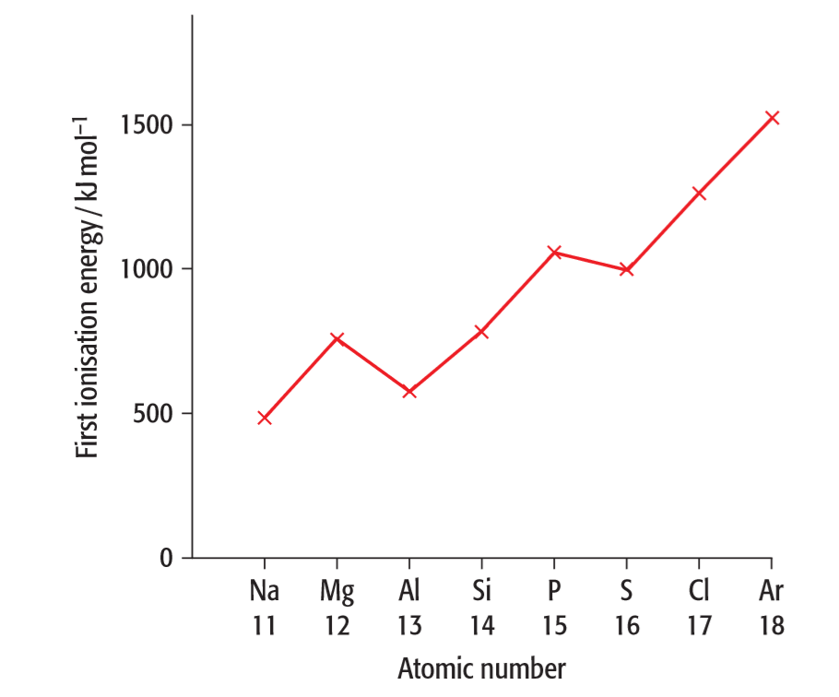



* + - Factor affecting the first ionization energy:

1. Charge of the nucleus

2. Distance between nucleus and the electron

3. Shielding effect from the inner shell of electron

4. Spain-pair repulsion[if applicable]

You can answer by the form of argument like this:

* the increase of the nucleus charge is out weight the increase in the distance between nucleus and electron, and the electron shells is constant, so the first ionization energy increase
* for the decrease at p orbit: the electron shell increase from s to p therefore have higher shielding effect and distance, slightly reduce the first ionization energy
* for the decrease at p3-4: the 3p orbit are all occupied by single electron at p3, and the addition of electron results in an electron pair which leads to the Spain pair repulsion and decrease the first ionization energy
  + M.P./B.P.

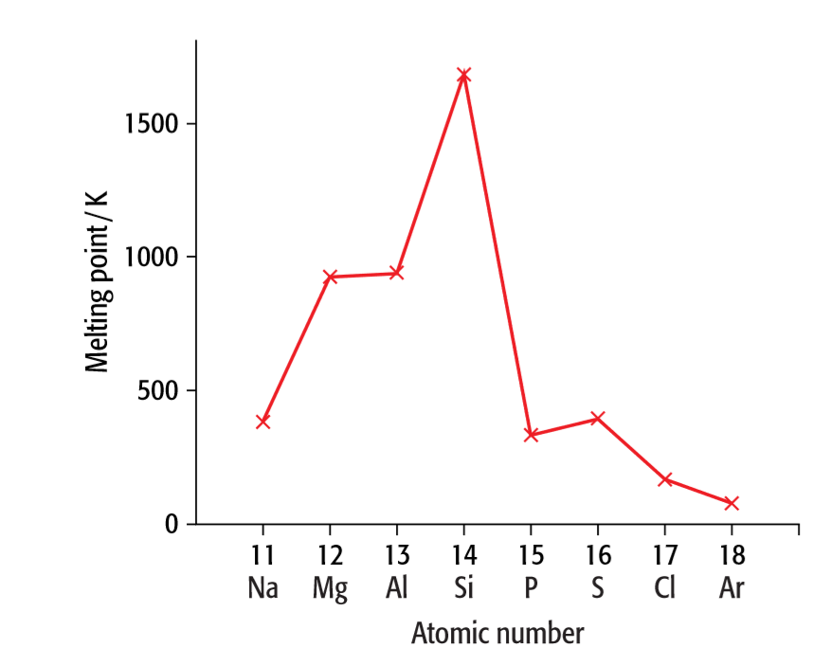



* + - The m.p. and b.p. are strongly related into the structure of elements

|  |  |  |  |  |
| --- | --- | --- | --- | --- |
| Elements | structure | Details of structure | Bond | IMF |
| Na | Gigantic metallic | Lattice | Metallic | Ionic |
| Mg | Gigantic metallic | Lattice | Metallic | Ionic |
| Al | Gigantic metallic | Lattice | Metallic | Ionic |
| Si | Gigantic covalent | lattice | Covalent | Covalent |
| P | Simple molecule | Red P4(tetratomic) | Covalent | Van der Waals’ |
| S | Simple molecule | Yellow S8(Octaineatomic) | Covalent | Van der Waals’ |
| Cl | Simple molecule | Green Cl2(diatomic) | Covalent | Van der Waals’ |
| Ar | Simple molecule | Ar(noble gas) | - | Van der Waals’ |

* + - The increase in m.p. in metallic is related

1. Higher charge density
2. More electron

These leads to stronger metallic bond

* + - The strongest m.p. in Si is related

1. Strong covalent bond in giant structure
2. Must break all if need to melt
   * + The variation in the rest is related to IMF

IMF is related to the number of electron and the size of molecules, which is directly related to the structure of the molecules

* + Electroconductivity

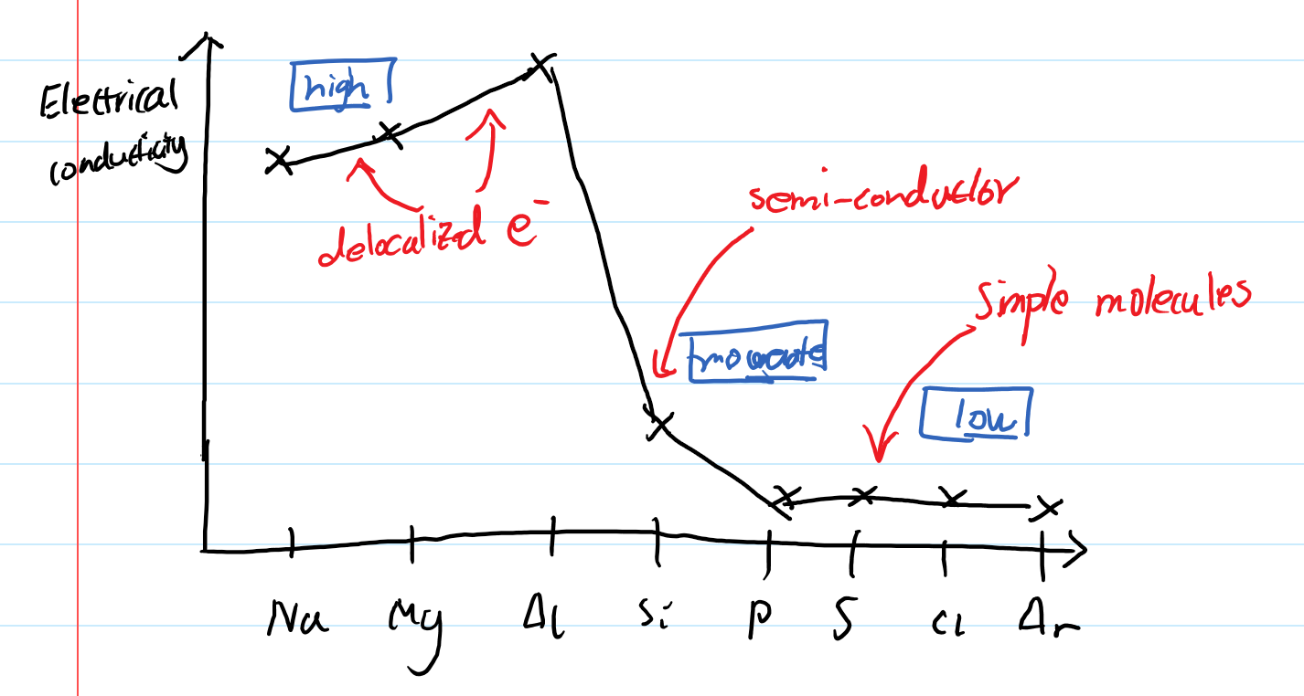

* + - Electroconductivity is depends on the structure of the elements:
      * Na/Mg/Al are metallic ions with ‘seas’ of electron therefore have delocalized electron and is the strong conductor
      * Si is the gigantic covalent therefore be the semiconductor (although not strong as graphite)
      * All the rest are simple molecule and are insulator
* Chemical properties
  + Reaction with oxygen

|  |  |  |
| --- | --- | --- |
| Element | Observation | Formula |
| Na | Orange-yellow flame  White product | 4Na + O2 -> 2Na2O (sodium oxide)  2Na + O2 -> Na2O2 (sodium peroxide) |
| Mg | Bright white flame  White product | 2Mg + O2 -> 2MgO |
| Al | White flame  White product/smoke | 4Al + 3O2 -> 2Al2O3 |
| Si | Slowly burns when heat strongly  White flame | Si + O2 -> SiO2 |
| P | Yellow flame  White smoke | P4 + 3O2 -> P4O6  P4 + 5O2 -> P4O10 (in excess oxygen) |
| S | Blue flame  Colorless gas | S + O2 -> SO2 |
| Cl | Does not react directly | - |

* + Reaction with chlorine

|  |  |  |
| --- | --- | --- |
| Element | Observation | Formula |
| Na | Bright orange flame  White product | 2Na + Cl2 -> 2NaCl |
| Mg | Bright white flame  White product | Mg + Cl2 -> MgCl2 |
| Al | yellow flame  pale yellow product | 4Al + 3Cl2 -> 2Al2Cl3 (Sublime) |
| Si | Slowly react when passed with chlorine gas  Colorless liquid | Si + 2Cl2 -> SiCl4 |
| P | Yellow flame  Mixtures of chlorides | P4 +6Cl2 -> 4PCl3  P4 + 10Cl2 -> PCl5 |
| S [Does not include in syllabus] | Slowly react when passed with chlorine gas  Orange liquid | 2S + Cl2 -> S2Cl2 |
| Cl | No reaction | - |

* + Reaction with water
    - Sodium

Na + H2O ->NaOH + H2

* + - Magnesium

In cold water: Mg + 2H2O ->Mg(OH)2 + H2 (Slowly)

In steam: Mg + H2O -> MgO + H2 (Vigrously)

* + Reaction of oxides with water

|  |  |  |  |  |  |
| --- | --- | --- | --- | --- | --- |
| Element | Oxidation number | Structure | Observation | pH | Formula |
| Na | +1 | Ionic | Dissolve exothermically | 14 | Na2O + H2O -> 2NaOH |
| Mg | +2 | Ionic | Slight reaction | 9 | MgO + 2H2O -> Mg(OH)2 + H2 |
| Al | +3 | Giant Ionic with covalent | No reaction | - | - |
| Si | +4 | Giant covalent | No reaction | - | - |
| P | +3  +5 | Simple molecules | P4O6 reacts with cold water  P4O10 reacts violently | 1-2 (phosphoric acid) | P4O6 +6H2O -> 4H3PO3  P4O10 + 6H2O -> 4H3PO4 |
| S | +4  +6 | Simple molecules | SO2 dissolve readily  SO3 dissolve violently | 1  0 | SO2 + H2O -> H2SO3  SO3 + H2O -> H2SO4 |
| Cl | +1  +4  +7 | - | Does not react with water | - | - |

* + - Amphoteric nature of Al2O3
      * It is a giant ionic with covalent characters so both basic and acidic behavior can be observed
      * With Acid: Al2O3 + 6HCl ->2AlCl3 + 3H2O
      * With Alkaline: Al2O3 + 2NaOH + 3H2O-> NaAl(OH)4 / (Na+ +Al(OH)4-)
  + Reaction of chloride

|  |  |  |  |  |  |
| --- | --- | --- | --- | --- | --- |
| Element | structure | Oxidation number | Observation | pH | Formula |
| Na | Giant Ionic | +1 | Dissolve | 7 | NaCl -> Na+ + Cl- |
| Mg | Giant Ionic with covalent | +2 | Dissolve | 6.5 | MgCl -> Mg+ + Cl- |
| Al | Simple molecule with ionic | +3 | Hydrolyses  In droplet steamy fume might appeared | 3 | AlCl3 + 3H2O -> Al(OH)3 + 3HCl |
| Si | Simple molecule | +4 | Hydrolyses | 1-2 | SiCl4 + 2H2O -> SiO2 + 4HCl |
| P | Simple molecule | +3  +5 | Hydrolyses | 1-2 | PCl3 + 3H2O -> H3PO4 + HCl |
| S [Not demand in syllabus] | Simple molecule | +1  +2  +4 | Hydrolyses | 1-2 | S2Cl2 + H2O -> SO2 +4HCl + 3S |
| Cl | - | - | No reaction | - | - |

* + - An ionic chloride dissolve in H2O
      * The pH depends on the polarizing effect when if form complex in water
    - Covalent Chlorides + H2O -> Acidic(steamy fume) – hydrolysis to produce HCl
      * Consider adding water to each side of the molecules and break them down(add Chlorine with H and other side with OH)
      * Then go for the most stable compound(SiO2, H3PO4)
      * Finally balanced the equation

**Group 2(Alkaline Earth Metal)**:

* Physical Properties:
  + Atomic Radius: increase from up to down

the atomic radius increase could be explain by following factor:

1. The number of shells of electron
2. The effective nuclear charge cause by the shielding effect of the inner electron shell
3. The attraction because of the nucleus charge

You can answer by the form of argument like this:

the increase attraction of the nucleus charge is out weight by the increase of shielding effect from the inner shell of electron, thus leading to the decrease of effective nuclear charge, and because the increase in the distance between nucleus and electron, so the atomic radius increase

|  |  |  |  |  |  |
| --- | --- | --- | --- | --- | --- |
|  | Be | Mg | Ca | Sr | Ba |
| Atomic radius/nm | 0.111 | 0.160 | 0.197 | 0.215 | 0.217 |

* + Ionization Energy: decrease from up to down

The decrease of ionization energy could be explain by the following factor:

1. Charge of the nucleus
2. Distance between nucleus and the electron
3. Shielding effect from the inner shell of electron

You can answer by the form of argument like this:

the increase of the nucleus charge is out weight by the increase of shielding effect from the inner shell of electron and the increase in the distance between nucleus and electron, so the first ionization energy decrease

|  |  |  |  |  |  |
| --- | --- | --- | --- | --- | --- |
|  | Be | Mg | Ca | Sr | Ba |
| 1st ionization energy/ KJmol-1 | 900 | 738 | 590 | 550 | 503 |

* + Electronegativity: decrease from up to down

Electronegativity is the ability for an atom to attract the electron.

Electronegativity is explain by the following factor:

1. The size of the atom(atomic radius)
2. The attraction from the nucleus because

You can answer by the form of argument like this:

As the atomic radius increase the bonding pair is further away from the electron so the attraction for it is weaker, therefore the electronegativity decrease

|  |  |  |  |  |  |
| --- | --- | --- | --- | --- | --- |
|  | Be | Mg | Ca | Sr | Ba |
| Electronegativity | 1.57 | 1.31 | 1.00 | 0.95 | 0.89 |

* + Melting Point: decrease from up to down[Except for **Mg** which has an unusual low m.p.]

|  |  |  |  |  |  |
| --- | --- | --- | --- | --- | --- |
|  | Be | Mg | Ca | Sr | Ba |
| Melting point/°C | 1278 | 649 | 839 | 769 | 729 |

* Chemical Properties
  + General properties
    - Reactive metals
    - Outer shell electron configuration ns2
    - Only one oxidation state of +2
    - Strong reducing agent
  + Reaction with oxygen

|  |  |  |  |
| --- | --- | --- | --- |
| Element | Observation | Formula | acidity |
| Be | Reluctant to burn, white flame | 2Be + O2 ->2BeO | amphoteric |
| Mg | Burns easily with a bright white flame | 2Mg+O2 ->2MgO | Basic |
| Ca | Difficult to ignite, flame tinged red | 2Ca + O2 ->2CaO | Basic |
| Sr | Difficult to ignite, flame tinged red | 2Sr + O2 ->2SrO  Sr + O2 ->SrO2  Notice Peroxide also formed | Basic |
| Ba | Difficult to ignied, flame tinged green | 2Ba + O2 -> 2BaO  Ba + O2 ->BaO2  Notice Peroxide also formed | Basic |

* + Reaction with water

|  |  |  |  |
| --- | --- | --- | --- |
| Element | Observation | Formula | acidity |
| Be | No reaction | - | - |
| Mg | Reacts vigorously with steam but very slowly with water | Mg+2H2O ->Mg(OH)2 + H2 | Weak alkaline  pH 9-11 |
| Ca | Reacts moderately forming the hydroxide | Ca+2H2O ->Ca(OH)2 + H2 | Weak alkaline  pH = 11 |
| Sr | Reacts rapidly forming the hydroxide | Sr+2H2O ->Sr(OH)2 + H2 | Alkaline  pH =13 |
| Ba | React vigorously forming the hydroxide | Ba+2H2O ->Ba(OH)2 + H2 | Strong alkaline  pH = 14 |

* + Reaction with dilute acid

|  |  |  |  |
| --- | --- | --- | --- |
| Element | Observation | Formula | acidity |
| Be | Reacts rapidly | Be+2HCl ->BeCl2 + H2 | neutral |
| Mg | Reacts vigorously | Mg+2HCl ->MgCl2 + H2 | natural |
| Ca | Reacts vigorously | Ca+2HCl ->CaCl2 + H2 | neutral |
| Sr | Reacts violently | Sr+2HCl ->SrCl2 + H2 | neutral |
| Ba | React violently | Ba+2HCl ->BaCl2 + H2 | neutral |

* + - All group 2 metal reacts with dilute HCl or HNO3, and it gets more vigorous down the group
    - If H2SO4 is used, the reaction still happened, but since sulphate solubility decrease down the group, you will get white precipitate starting from Ca/Sr/Ba
    - If the concentration of HNO3 increase, then in moderate level it tends to give nitrogen oxide, and in concentrated level it tends to give nitrogen dioxide
  + Reaction with chlorine

|  |  |  |  |
| --- | --- | --- | --- |
| Element | Observation | Formula | acidity |
| Be | Reacts rapidly | Be+2HCl ->BeCl2 + H2 | neutral |
| Mg | Reacts vigorously | Mg+2HCl ->MgCl2 + H2 | natural |
| Ca | Reacts vigorously | Ca+2HCl ->CaCl2 + H2 | neutral |
| Sr | Reacts violently | Sr+2HCl ->SrCl2 + H2 | neutral |
| Ba | React violently | Ba+2HCl ->BaCl2 + H2 | neutral |

* + Reaction of oxides

|  |  |  |
| --- | --- | --- |
| Compound | Reaction with water | Reaction with dilute acids |
| BeO | No reaction | BeO+2HCl ->BeCl2 + 2H2O |
| MgO | Apparently no change of the solid, pH of mixture is 9 | Mg(OH)2+2HCl ->MgCl2 + 2H2O |
| CaO | Exothermic reaction, produce slightly soluble slaked lime, pH of the mixture is 12 | CaO+2HCl ->CaCl2 + 2H2O |
| SrO | Produce a colorless solution of pH 14 | SrO+2HCl ->SrCl2 + 2H2O |
| BaO | Produce a colorless solution of pH 14 | BaO+2HCl ->BaCl2 + 2H2O |

* + - All group 2 oxides react with water in the general formula to give hydroxides

MO + H2O -> M(OH)2

* + - For the reaction with HCl and HNO3 all compound can react to form salts and water, but for H2SO4 the situation is complex as SrSO4 and BaSO4 are insoluble white percipitate
  + Reaction of hydroxides

|  |  |
| --- | --- |
| Compound | Reaction with dilute acids |
| Be(OH)2 | Be(OH)2+2HCl ->BeCl2 + 2H2O |
| Mg(OH)2 | Mg(OH)2+2HCl ->MgCl2 + 2H2O |
| Ca(OH)2 | Ca(OH)2+2HCl ->CaCl2 + 2H2O |
| Sr(OH)2 | Sr(OH)2+2HCl ->SrCl2 + 2H2O |
| Ba(OH)2 | Ba(OH)2+2HCl ->BaCl2 + 2H2O |

* + - This is the typical reaction of acid – base reaction
  + Reaction of carbonates

|  |  |  |
| --- | --- | --- |
| Compound | Reaction with water | Reaction with dilute acids |
| BeCO3 | Insoluble in water | BeCO3 +2HCl ->BeCl2 + CO2 + H2O |
| MgCO3 | Insoluble in water | MgCO3 +2HCl ->MgCl2 + CO2 + H2O |
| CaCO3 | Insoluble in water | CaCO3 +2HCl ->CaCl2 + CO2 + H2O |
| SrCO3 | Insoluble in water | SrCO3 +2HCl ->SrCl2 + CO2 + H2O |
| BaCO3 | Insoluble in water | BaCO3 +2HCl ->BaCl2 + CO2 + H2O |

* + - All group 2 carbonates are insoluble in water
    - They all react with dilute acids to give salts, water and carbon dioxide
    - Because the decrease solubility of SrSO4 and BaSO4, they will prevent the reaction goes much further when react with H2SO4
  + Thermal decomposition of nitrates and carbonates
    - The thermal stability of the compound is related to the ability for the cation to polarize the anion and results in the formation of oxides. The cation up the group is smaller, having a higher charge density, therefore have stronger polarizing effect and less thermal stability (this is not requiring by AS level)
    - Nitrates

|  |  |
| --- | --- |
| Element | Formula |
| Be | 2Be (NO3)2 ->2BeO + 4NO2 + O2 |
| Mg | 2Mg(NO3)2 ->2MgO + 4NO2 + O2 |
| Ca | 2Ca(NO3)2 ->2CaO + 4NO2 + O2 |
| Sr | 2Sr(NO3)2 ->2SrO + 4NO2 + O2 |
| Ba | 2Ba(NO3)2 ->2BaO + 4NO2 + O2 |

* + - * The thermal stability increases down the group, and the reaction gives out NO2 as brown gas
      * Mg and Ca may form water crystal therefore dissolve into a colorless solution before decomposing
    - Carbonates

|  |  |
| --- | --- |
| Element | Formula |
| Be | BeCO3 ->BeO + CO2 |
| Mg | MgCO3 ->MgO + CO2 |
| Ca | CaCO3 ->CaO + CO2 |
| Sr | SrCO3 ->SrO + CO2 |
| Ba | BaCO3 ->BaO + CO2 |

* + - * The thermal stability increase down the group
  + Solubility of hydroxides and sulfates
    - They only demand the statement without explain because there is no simple explanation for it in AS level
    - The solubility for hydroxides increase down the group
    - The solubility for sulfates decrease down the group
* Application
  + Ca
    - Conversion between limes

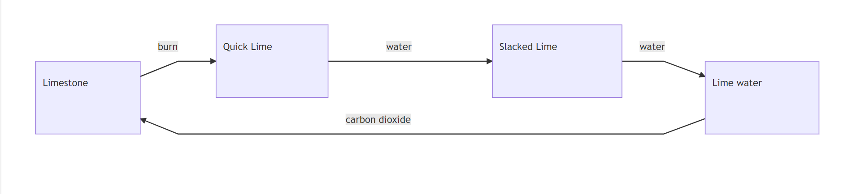

* + - Lime(calcium carbonate) is used to make concrete by forming quick lime(Calium oxide) and marble(also calcium carbonate) is use as building material

CaCO3 –(heat in rotating lime kilin)->CaO + CO2

* + - Slacked lime(calcium hydroxide) are use to maintain the soil pH by neutralizing the acid

Ca(OH)2+2HCl ->CaCl2 + 2H2O -

* + Mg
    - MgO is used to make blast furnace lining because it is thermal insulator and has high mp(it is not acidic)
    - Mg(OH)2 is used in toothpaste and indigestion tablets as anti-acid

Mg(OH)2 + 2H+ -> Mg2+ + 2H2O

**Group 17(Halogen):**

* Physical Properties

|  |  |  |  |
| --- | --- | --- | --- |
| Element | Color | Boiling point/K | Electronegativity |
| F2 | Pale-yellow gas | 85 | 4.0(strongest) |
| Cl2 | Yellow green gas | 238 | 3.0 |
| Br2 | Dark red liquid | 332 | 2.8 |
| I2 | Dark gray solid/ Purple Vapour | 457 | 2.5 |

* + The color intensity increases down the group
  + The volatility decrease down the group

1. Halogen are diatomic simple molecule

2. Main IMF is Van der Vaal’s force

3. As the atomic size increase and electron number increase, the Van der Waal’s force increase

* + The electronegativity decrease down the group
    - As the atomic radius increase the bonding pair is further away from the electron so the attraction for it is weaker, therefore the electronegativity decrease
* Chemical Properties:
  + General properties
    - The reactivity decrease down the group because the electron are further apart from the nucleus, having more shielding effect therefore are less attractive for electrons
    - Halogens - diatomic molecules
    - Halogens elements are strong Oxidizing agent
    - Outer shell electron configuration = ns2p5
  + Elements
    - Reactions with hydrogen

|  |  |  |
| --- | --- | --- |
| Element | Observation | Formula |
| F | Explode under all condition (even at ~50K) | F2 + H2 -> 2HF |
| Cl | Explode under sunlight/bright light | Cl2 + H2 -> 2HCl |
| Br | Slow reaction, only happen on heating around ~400K | Br2 + H2 -> 2HBr |
| I | **Incomplete** reaction under heating around 1000K/platinum catalyst presents | I2 + H2 2HI |

* + - Comparison between the reactions:
      * Extent of reaction decrease
      * Activation energy increase
      * The decrease in the extent of reaction is because of:

1. The bond length increase down the group in X-X bond, therefore the activation energy decrease (F-F is special case because the distance between atoms is too small and the repulsion in electron is helping to break the bond)
2. H-X bond length decrease down the group, the longer the bond length is the less energy it require to release to form, and this outweigh the energy require to break the bond(it is much more significant compare with the activation energy)
   * Reaction of Halides
     + Except H-F, all of the halides are strong acids and can complete ionized
       - H-F can not complete ionized because of the strong bond energy of it
     + Thermal stability
       - the thermal stability decrease down the group: H-F is most stable and HI is least stable
       - This is because the bond energy of H-F is highest and H-I is lowest because H-F has shortest bond length and require more energy to break it, H-I has the longest bond length and require least energy to break it

|  |  |  |  |  |
| --- | --- | --- | --- | --- |
|  | F | Cl | Br | I |
| H-X | 562 | 431 | 366 | 299 |
| C-X | 467 | 346 | 290 | 228 |
| Heating (putting red-hot glass rod into it) Observation | No reaction | No reaction | Evidence of Brownish coloration | Immediately purple vapor |

* + - Test for halides ions

|  |  |  |
| --- | --- | --- |
| Halide ion | Reaction with **acidified** AgNO3(aq) | Observation with NH3(aq) |
| Cl | White ppt. | Dissolve in dilute ammonia |
| Br | Cream ppt. | Dissolve with concentrated ammonia |
| I | Yellow ppt. | Does not dissolve |

* + - * When added to NH3, Ag+ will form a complex and it is favor in RHS when NH3 is conc.

2NH3 + Ag+ [Ag(NH3)2]+(aq)

* + - * However, this depends on the extent to which the AgX is soluble in water, because AgCl is mostly soluble, AgBr is partly soluble and AgI is insoluble in water, thus there is no complex formed in AgI but both formed in AgCl and AgBr
  + Replacement reaction of ions:
    - The more reactive element will replace the less reactive element’s ion in the ionic compound
    - Cl2 + 2Br- -> Br2 + 2Cl-
    - This is actually due to the different oxidizing power of the element:
      * Cl ->Br-/I-
      * Br ->I-
  + Reaction as oxidizing agent/reducing agent
    - Cl2/Br2 can oxidize Fe2+to Fe3+

Cl2 + 2Fe2+ ->2Fe3+ + 2Cl-

* + - Fe3+ can oxidize I- back to I2

2Fe3+ + 2I- -> I2 + 2Fe2+

* + Reaction with oxidizing acid [See Redox Section]
  + Reaction with non-oxidizing acid
    - Non-oxidizing Acid(H3PO4) will only lead to the protonation of halide ions and seen the steamy fumes coming out of the reaction as HX(g) without any further oxidization happened
    - H3PO4 + KX -> KH2PO4 + HX
  + Chlorine react with sodium hydroxide
    - In cold dilute NaOH:

Cl2 +2OH- ->Cl- + ClO- +H2O

Cl(0) converted to Cl-(-1)

* + - In hot, conc. NaOH:

3Cl2 + 6OH- ->5Cl- + ClO3- + 3H2O

This is called **disproportion** of chlorine because the oxidation number of Cl(0) both increase to Cl(5+)and decrease to Cl(1-) in the reaction

This is because at higher temperature the ClO- will decompose into 2Cl- + ClO3-, which the chlorine gets disporpotion

* Application & Production
  + Chlorine produced by electrolysis of chloride
  + Bromine and iodine are produced using chlorine gas to oxidize the bromide and iodide ions presents in sea water
  + Pure Florine is hard to make because it will even make reaction with water
  + Chlorine is used in water purification because it has strong oxidizing power which can distrust the bacterial metabolism

In water the following equilibrium happened:

Cl2 + H2O HCl + HClO

HClO + H2O H3O+ +OCl-

Both Cl2 and HClO are oxidizing agent therefore have the ability to kill the bacteria

* + NaOH and Cl can be used to make bleach(NaClO) which have cleaning effect and can wash toilets and ‘kills’ microorganism

Cl2 + OH- Cl- + OCl- + H2O

Pale yellow bleach product is formed when the reaction used Ca(OH)2

* + Manufacture of PVC: hard and good thermal stability
  + Manufacture of Halogenated hydrocarbons(CFC/PVC)
  + AgBr used in photography
  + CClBrF2 as fire exhausters(inert)
  + I2 as mild antiseptic [solution of iodine in alcohol]

**Nitrogen and Sulfur:**

* Nitrogen
  + Lack of reactivity
    - Nitrogen is lack of reactivity because the N≡N bond is a triple covalent bond and have strong bond energy, therefore demanding high activation energy and results in the unreactive nature of Nitrogen
  + Structure and acidity
    - Ammonia(NH3)

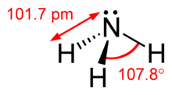

- Pyramidal because of the lone pair on N

- Bond angle 107°

- Alkaline Gas

- ability to form H-bond because of the strong electronegativity of N

- NH3 + H+ NH4+ (NH4+ is the conjugate acid to NH3 base)

* + - Ammonium(NH4+)

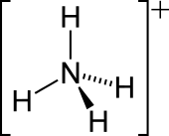

* Tetrahedral because of the dative covalent bond form with H
* Can be displaced by warming with a strong base:

NH4+ + OH- ->NH3 + H2O

* + Industrial application
    - Produce fertilizer

4NH3 + 5O2 ->4NO + 6H2O

* + - Produce nitric acid

2NO + O2 -> 2NO2

2NO2 -> 2N2O4

3N2O4 + 2H2O -> 4HNO3

* + Environmental consequence
    - Overusing nitrates will enter the water
    - Leads to Eutrophication (bloom of algae that cause environmental problem)
    - Potential harmful to human body
  + Nitrogen oxides
    - These(NOx) are produced when nitrogen react with oxygen in internal combustion engine
    - They have potential harmful effect to the environment by helping the formation of the SO3 in air

SO2 + NO2 -> NO + SO3

* + - Car engine can have catalytic converter (usually use platinum)to reduce these pollutants

2CO + 2NO -> 2CO2 + N2

* + Harbor process[removed from syllabus]
    - N2 + 3H2
    - 200 atm
    - Iron catalyst
    - 750K
* Sulfur
  + Formation of acid rain

1. When sulfur contain fossil fuel is burnt in internal combustion engine: SO2 is formed

S + O2 ->SO2

1. SO2 reacted with O2 in the air to produce SO3(catalyst by NO2 – homogenous catalyst)

2SO2 +O2 ->2SO3

1. SO3 then react with water in the clouds to produce H2SO4, which formed the acid rain

H2O + SO3 -> H2SO4

* + Harmful effect of the acid rain:
    - Plants(trees)
    - Rivers, streams, lakes(damage the food chain because the aquatic animals are sensitive to pH, and the reduce of food will lower the number of other number in the food chain)
    - Buildings, statues(marble), metal structures
  + Sulfuric Acid made of contact process[disappear from syllabus]
    - SO2 + O2
    - Catalyst V2O5
    - 1 atmosphere
    - 450°C